Social Media Posts
Schools can use the provide images and content to promote messaging to their school community about the importance of balancing technology use. The images are available for download on the Connected, Not Controlled web page.
For Use By Schools
Do you know how digital tech can impact your mental health? 🤔 Too much screen time can lead to anxiety, depression, and low self-esteem. Let's talk about it! How do you balance your tech use? Find more digital tech facts at wechu.org/cnc | 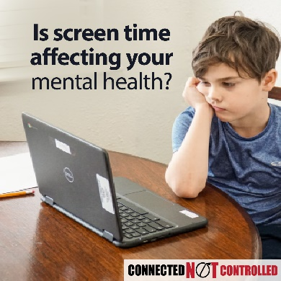
🚨 Digital Tech & Mental Health Alert! 🚨  Did you know that more screen time can mean more stress and anxiety? From increased anxiety and depression to multitasking, it's time to take control of our screen habits.  Remember: balance is key! What are your favorite ways to unplug?! Find more ideas at wechu.org/cnc | 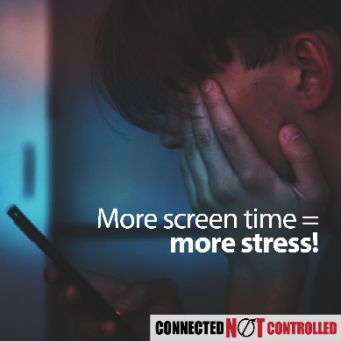
🌙💤 Are screens stealing your sleep? 😱 Many teens are spending over 5 hours a day on screens! That’s too much! Balance is the key! 🗝️ Aim for 8-10 hours of sleep and 60 minutes of fun physical activity daily. Remember, good sleep helps you shine during the day! ✨💪 Let's make healthier choices together! What’s your favorite way to stay active? Drop a comment! ⬇️  Find more tips at wechu.org/cnc | 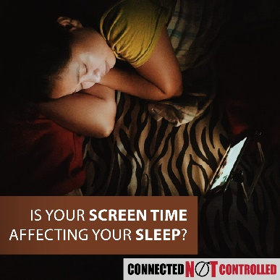
Feeling down after scrolling through social media? 😞 📱💕 Social media has pros and cons! On one hand, it helps us connect, especially for those who may feel alone. On the other, it can lead us comparing ourselves to peers and cyberbullying. 😔 Let’s choose kindness and support each other! Who’s your go-to person for support? Tag them below! 👇✨  Find more support at wechu.org/cnc | 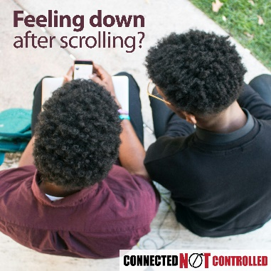
Are you spending too much time on screens? You're not alone!  It's time to take control! Here are some tips to balance screen time:  1️⃣ Set screen-free times and spaces. 📱  2️⃣ Set a time limit for gaming. 🎮  3️⃣ Turn off screens 1 hour before bed. 💤  Learn to use digital media wisely and be good digital citizens. How do you manage screen time? Share your tips! 👇💬  Find resources at wechu.org/cnc | 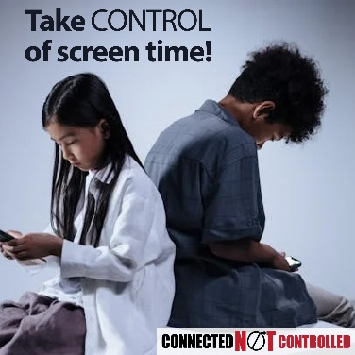

Throughout the challenge period, social media posts will be posted on WECHU social media accounts (in English). This content will promote the challenge and provide messaging about balancing digital technology use, engaging parent/caregivers and directing them to information and resources. Schools are encouraged to share or repost the content.
Facebook: @TheWECHU X: @TheWECHU Instagram: @thewechu

Announcements

Submission Period:
- Attention students! Are you ready to use your voice for change? The Connected, Not Controlled PSA Video Challenge is here! We want YOU to create a 30-second video about digital well-being and responsible tech use. The best videos will win prizes, and schools with the most participation will be recognized!
  - Your video must include a fact about technology’s impact on health and well-being and a call to action.
  - The deadline to submit is March 31, 2026.
  - Let’s stay connected, not controlled! Visit wechu.org/cnc for more details.
- Have you heard about the Connected, Not Controlled Challenge? Windsor-Essex County students in grades 6 to 12 can create and upload a 30-second PSA video to raise awareness about the effects of digital technology use on their mental health and well-being. The video submission period runs from March 2nd to March 31st. Enter your PSA video and you could win $300 and other cool prizes! Visit wechu.org/cnc for more information.
- Attention [name of school] students in grades 6 to 12! Are you ready to make a difference? Introducing the Connected, Not Controlled Challenge! Create a 30-second PSA video showcasing how digital technology can impact your mental health and well-being. From March 2nd to March 31st, upload your video and compete for a chance to win $300 and awesome prizes! Get all the details at wechu.org/cnc and let your voice be heard!
- Time is running out, [name of school] students! Don’t miss your chance to enter the Connected, Not Controlled Challenge! Submit your 30-second PSA video about digital tech and mental health by March 31st for a shot at $300 and other awesome prizes! Visit wechu.org/cnc and get your entry in before it’s too late!

Voting Period:
- The Connected, Not Controlled Challenge submission period has closed. Starting April 27th, you can vote daily for your favourite Connected, Not Controlled Challenge video. Visit wechu.org/cnc to vote.
- Have you been voting daily for your favourite Connected, Not Controlled Challenge video? Voting closes May 4th, visit wechu.org/cnc and vote today.

Assembly/ Student Council Pitch
- Students, are you ready to use your voice to make a difference, get creative, and even win prizes? We are here to introduce the Connected, Not Controlled PSA Video Challenge! This is your chance to use your voice and creativity to raise awareness about how digital technology impacts youth well-being and daily lives.
Here’s the challenge:
  - Create a 30-second PSA video that includes a fact about technology’s effects and a call to action.
  - Submit you video between March 2 and March 31, 2026
  - Win prizes for the best videos and help your school compete for the top participation award!
- Technology is everywhere, but are we connected, or controlled? Excessive screen time can affect mental health, sleep, relationships, and even school performance. It’s time to start the conversation! So make a plan, gather a few friends, and start filming! Visit wechu.org/cnc for all the details. Let’s create change—one video at a time!
- Have you heard about the Connected, Not Controlled Challenge? Windsor-Essex County students in grades 6 to 12 can create and upload a 30-second PSA video to raise awareness about how the use of digital technology can affect their well-being and daily lives. The video submission period runs from March 2nd to March 31st. Enter your PSA video and you could win $300 and other cool prizes! Visit wechu.org/cnc for more information.
- Have you entered the Connected, Not Controlled Challenge? It’s not too late, Windsor-Essex County students in grades 6 to 12 can create and upload a 30-second PSA video to raise awareness about how the use of digital technology can affect their well-being and daily lives. The video submission period runs until March 31st. Enter your PSA video and you could win $300 and other cool prizes! Visit wechu.org/cnc for more information.
- Starting April 27th, you can vote for your favourite Connected, Not Controlled Challenge Video. Voting closes May 4th visit wechu.org/cnc to vote.
- Have you voted for your favourite Connected, Not Controlled Challenge video yet? Voting closes May 4th, visit wechu.org/cnc to vote.

TV Image
Available for download on the Connected, Not Controlled web page.


Poster
Available for download on the Connected, Not Controlled web page.


